**Lab manual 12!**

**Passing arrays to functions**

**Task 1**:

Write a C++ program, which declares, input and displays an array of 10 elements. It then declares another array of the same size, and copies the elements of the first array in that order but in reverse order by passing both arrays in a function named reverse.

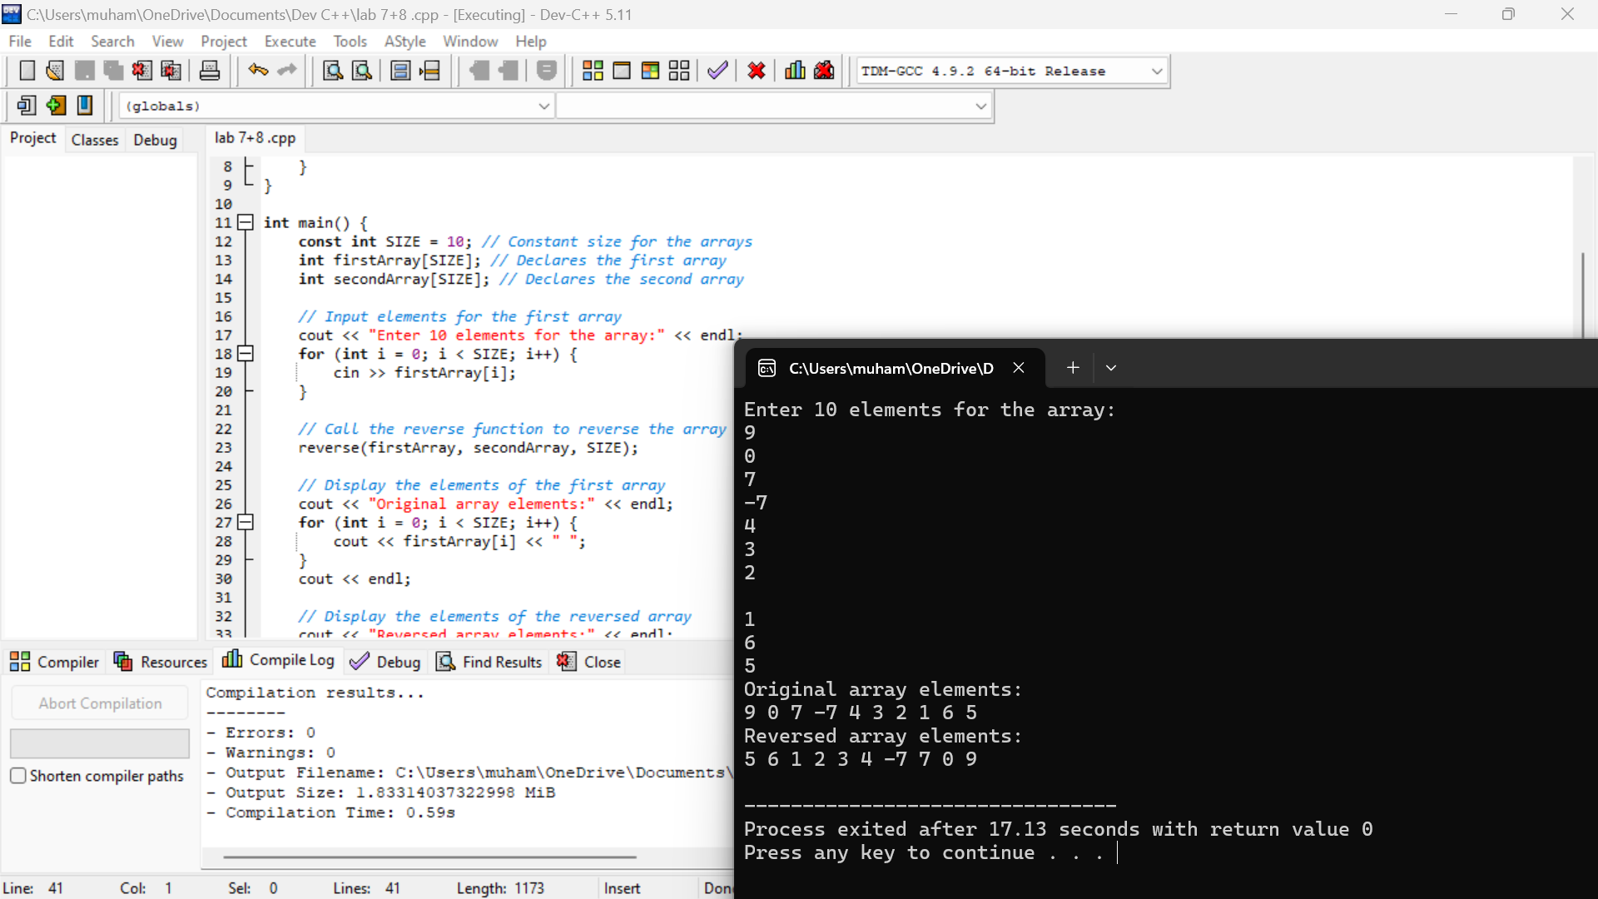

**Task 2**:

Write a C++ program which enters and displays 2 arrays. The program should ask the user about the size of the array first. It then swaps the data of arrays using a function. For Example Arr1= 123456 Arr2= 987067 After swapping it will become Arr1=987067 Arr2= 123456.

